Archimedean Solid

Definition
# Source: AI Source: Provided by: [Data Path: Persons Table -> ID Column: 1, Name_En Column: Motasem Essam] -> From: [ChatGPT] on [7/25/2026]
An Archimedean Solid is a convex, uniform polyhedron composed of two or more different types of regular polygonal faces, arranged in the same way around every vertex.
All faces are regular polygons, but unlike Platonic solids, they are not all the same polygon type.
There are 13 classical Archimedean solids. They are named after the ancient Greek mathematician <Entity value="Archimedes" category="people" disambig="Ancient Greek mathematician"/>. <Cite refs={["turn766214search0","turn766214search1","turn766214search2"]}/>

Geometric Structure
# Source: AI Source: Provided by: [Data Path: Persons Table -> ID Column: 1, Name_En Column: Motasem Essam] -> From: [ChatGPT] on [7/25/2026]
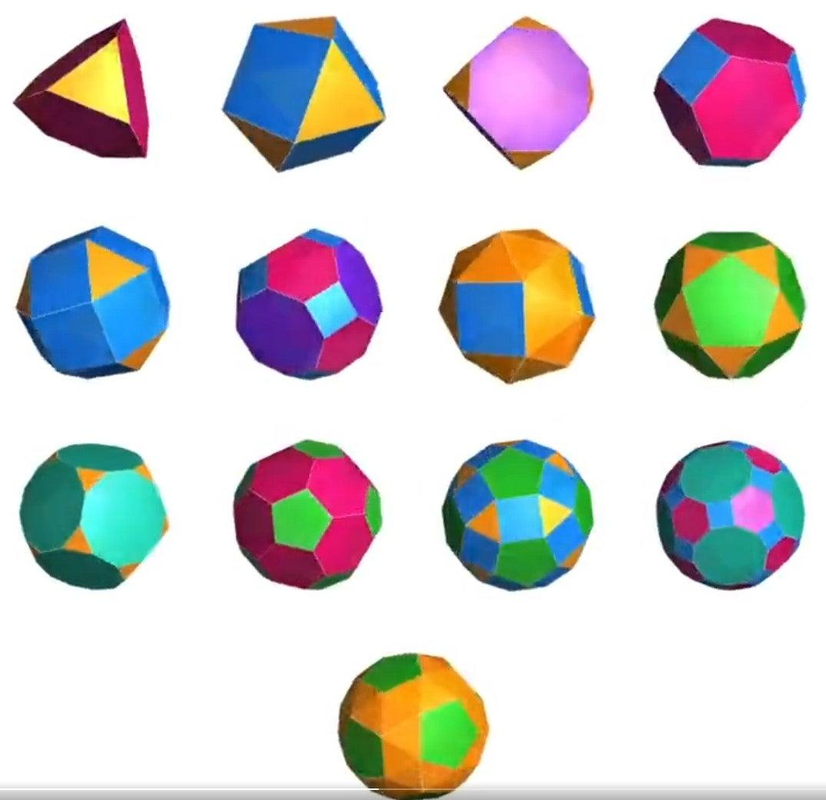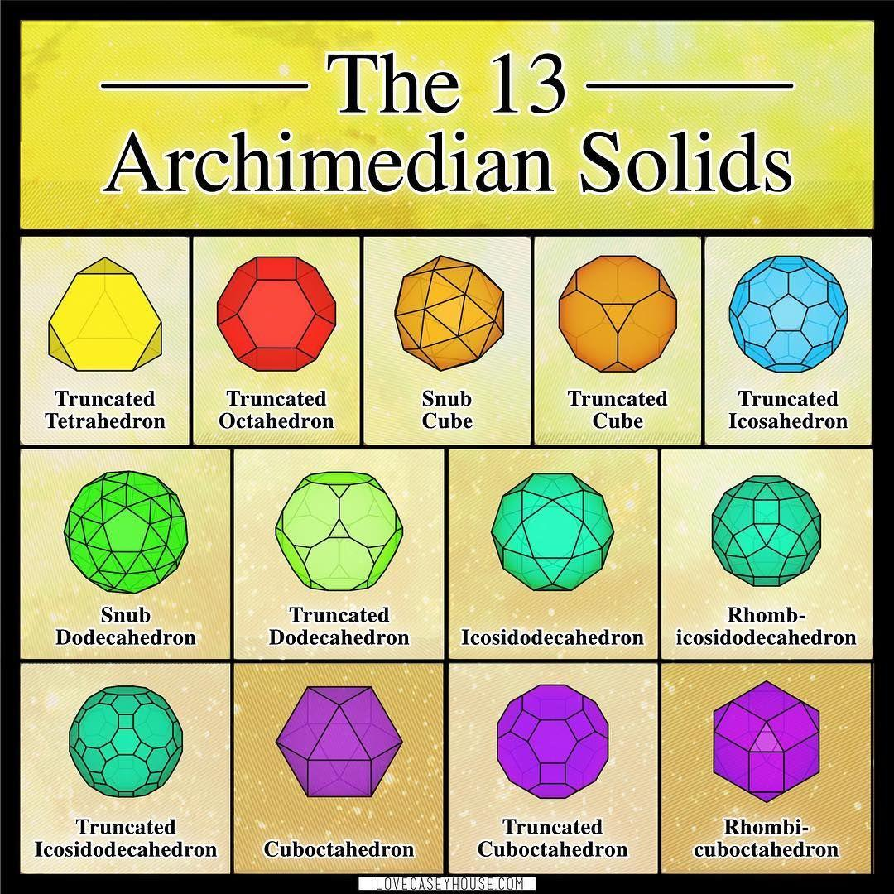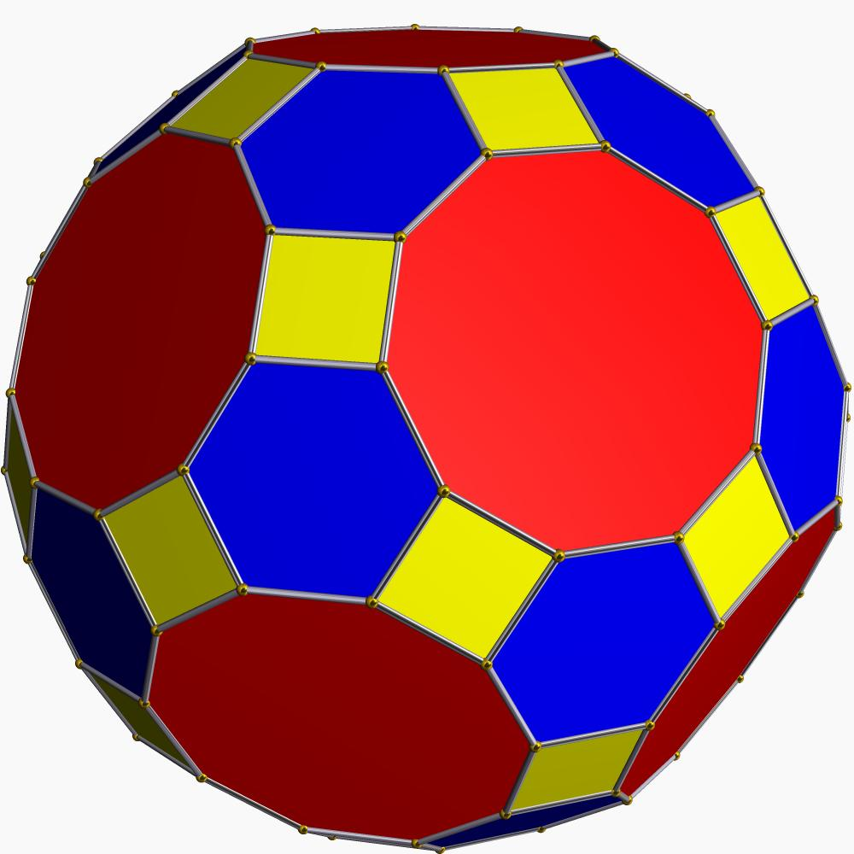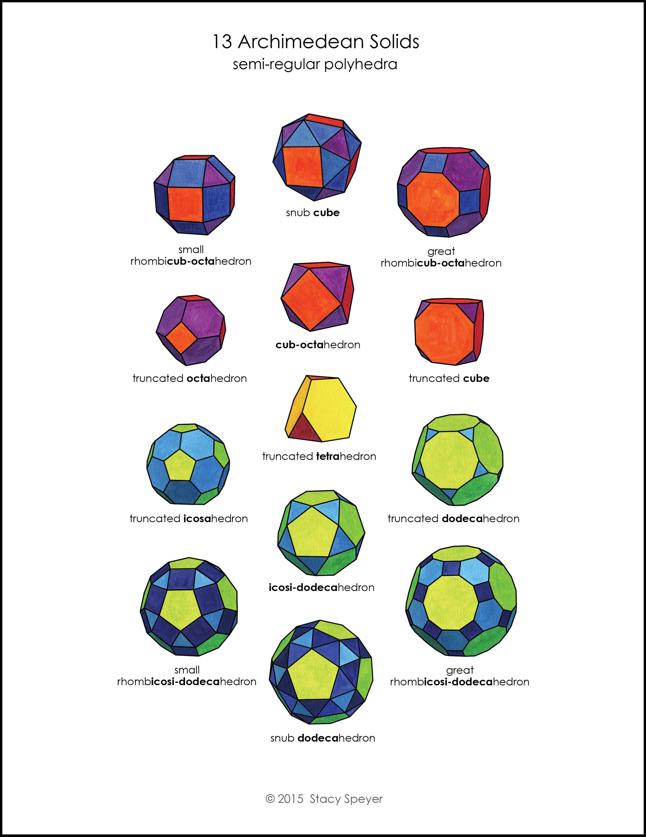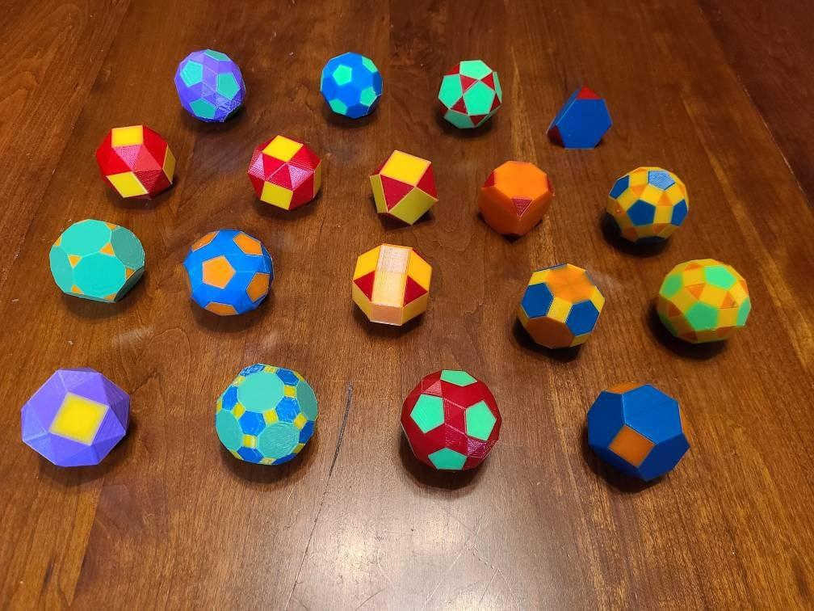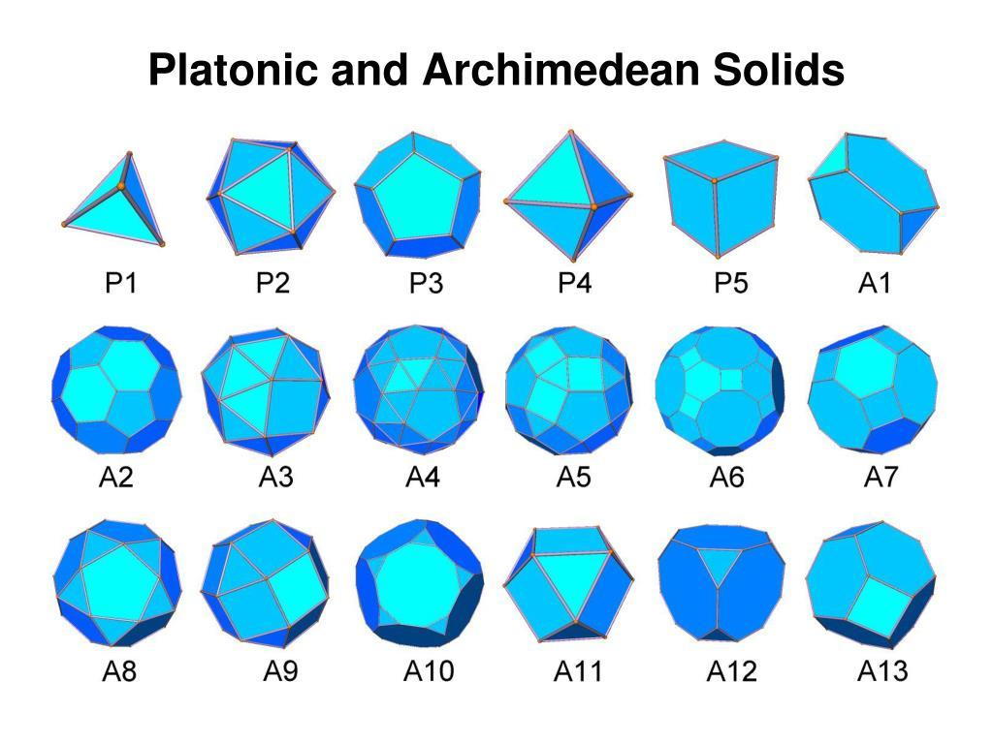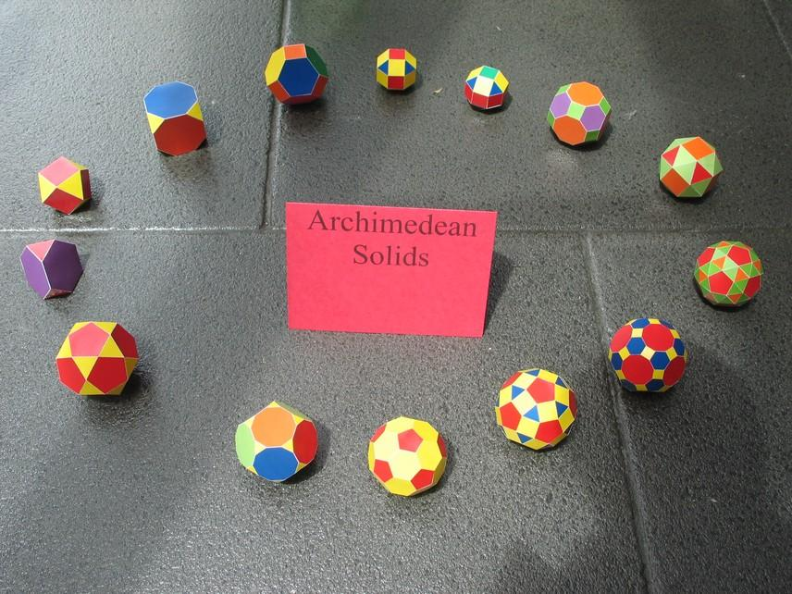
An Archimedean Solid has the following structural characteristics:
- Regular Polygonal Faces: Every face is a regular polygon, such as an equilateral triangle, square, pentagon, hexagon, octagon, or decagon.
- Multiple Face Types: Each solid contains at least two different polygon types.
- Identical Vertices: The same arrangement of faces occurs around every vertex.
- Equal Edge Lengths: All edges of a given Archimedean solid have the same length.
- Convex Structure: The solid has no inward indentations or self-intersecting faces.
- Uniform Symmetry: Its symmetry allows any vertex to be mapped onto any other vertex.

Types of Archimedean Solids
# Source: AI Source: Provided by: [Data Path: Persons Table -> ID Column: 1, Name_En Column: Motasem Essam] -> From: [ChatGPT] on [7/25/2026]
There are 13 classical Archimedean solids:
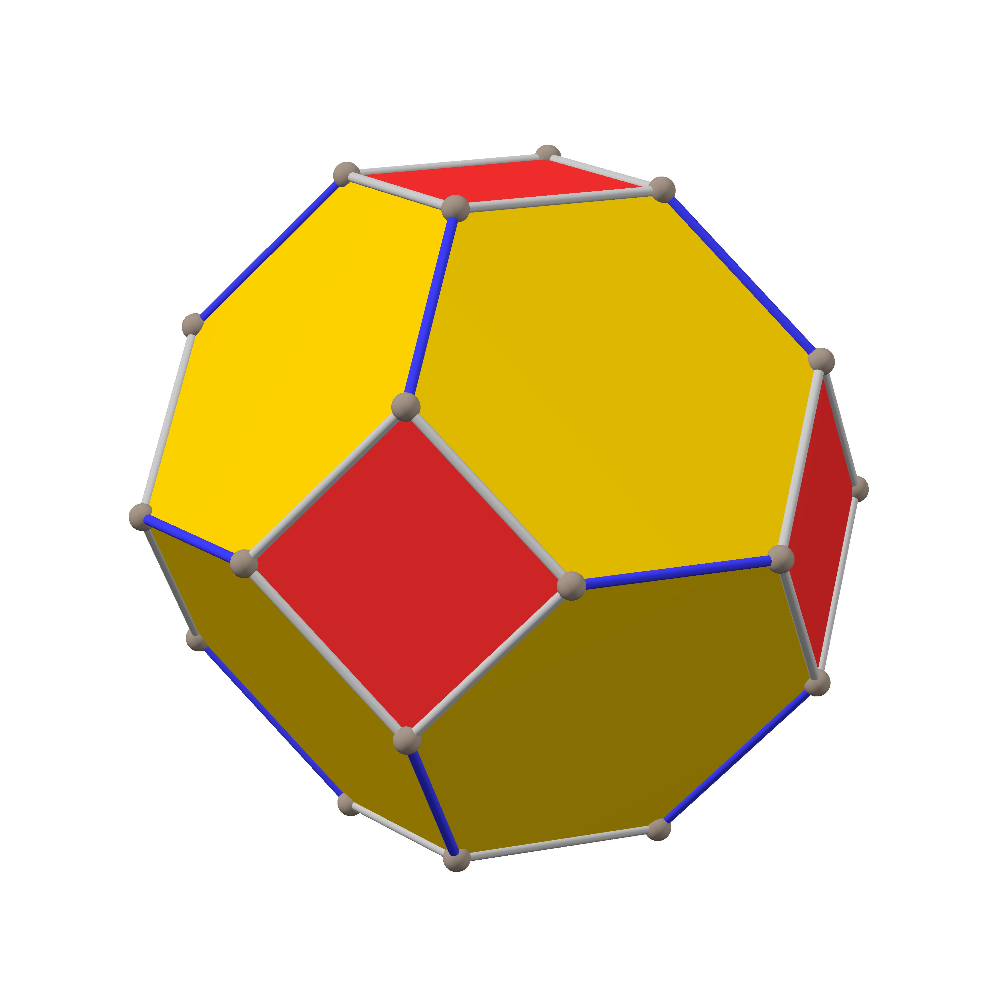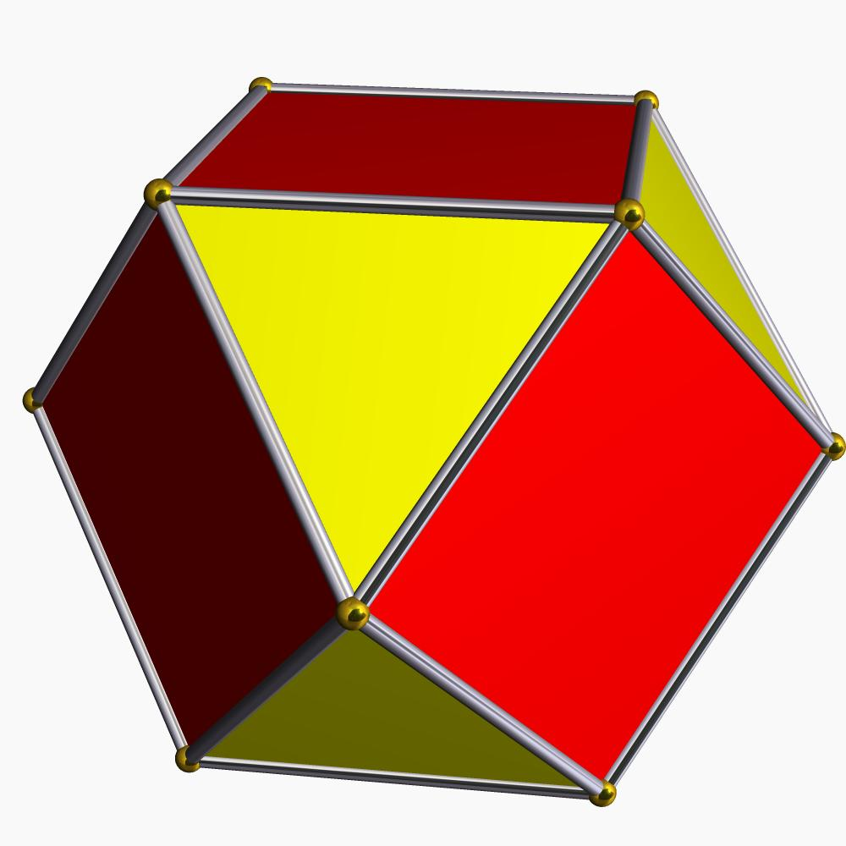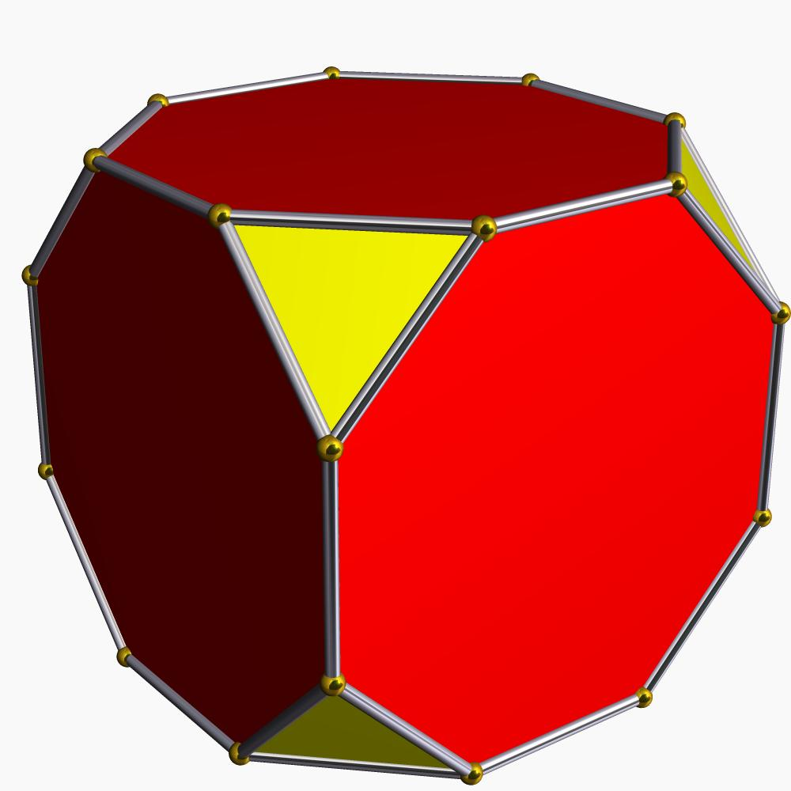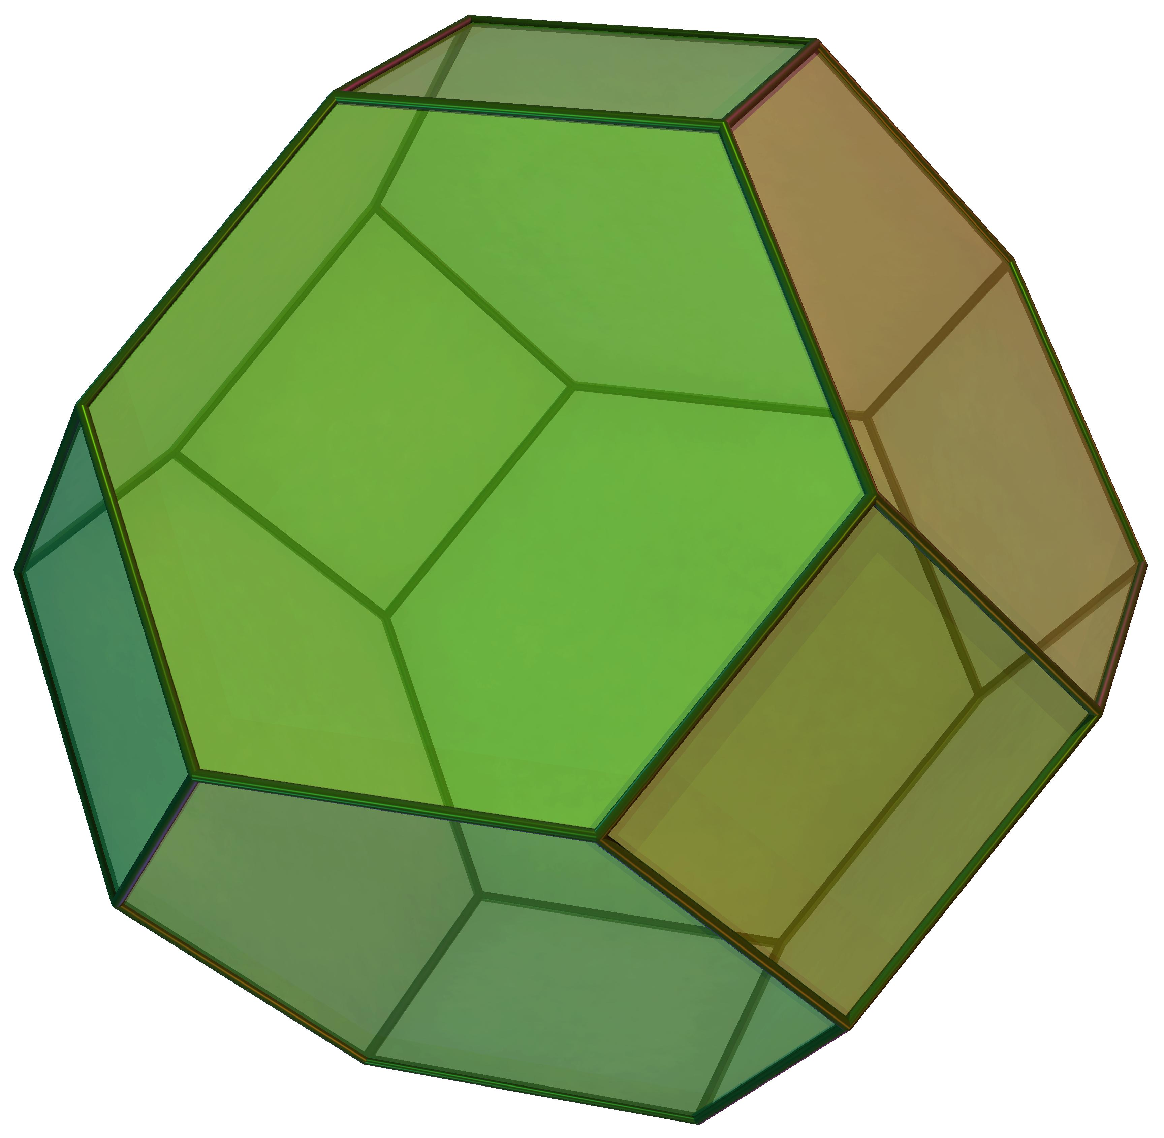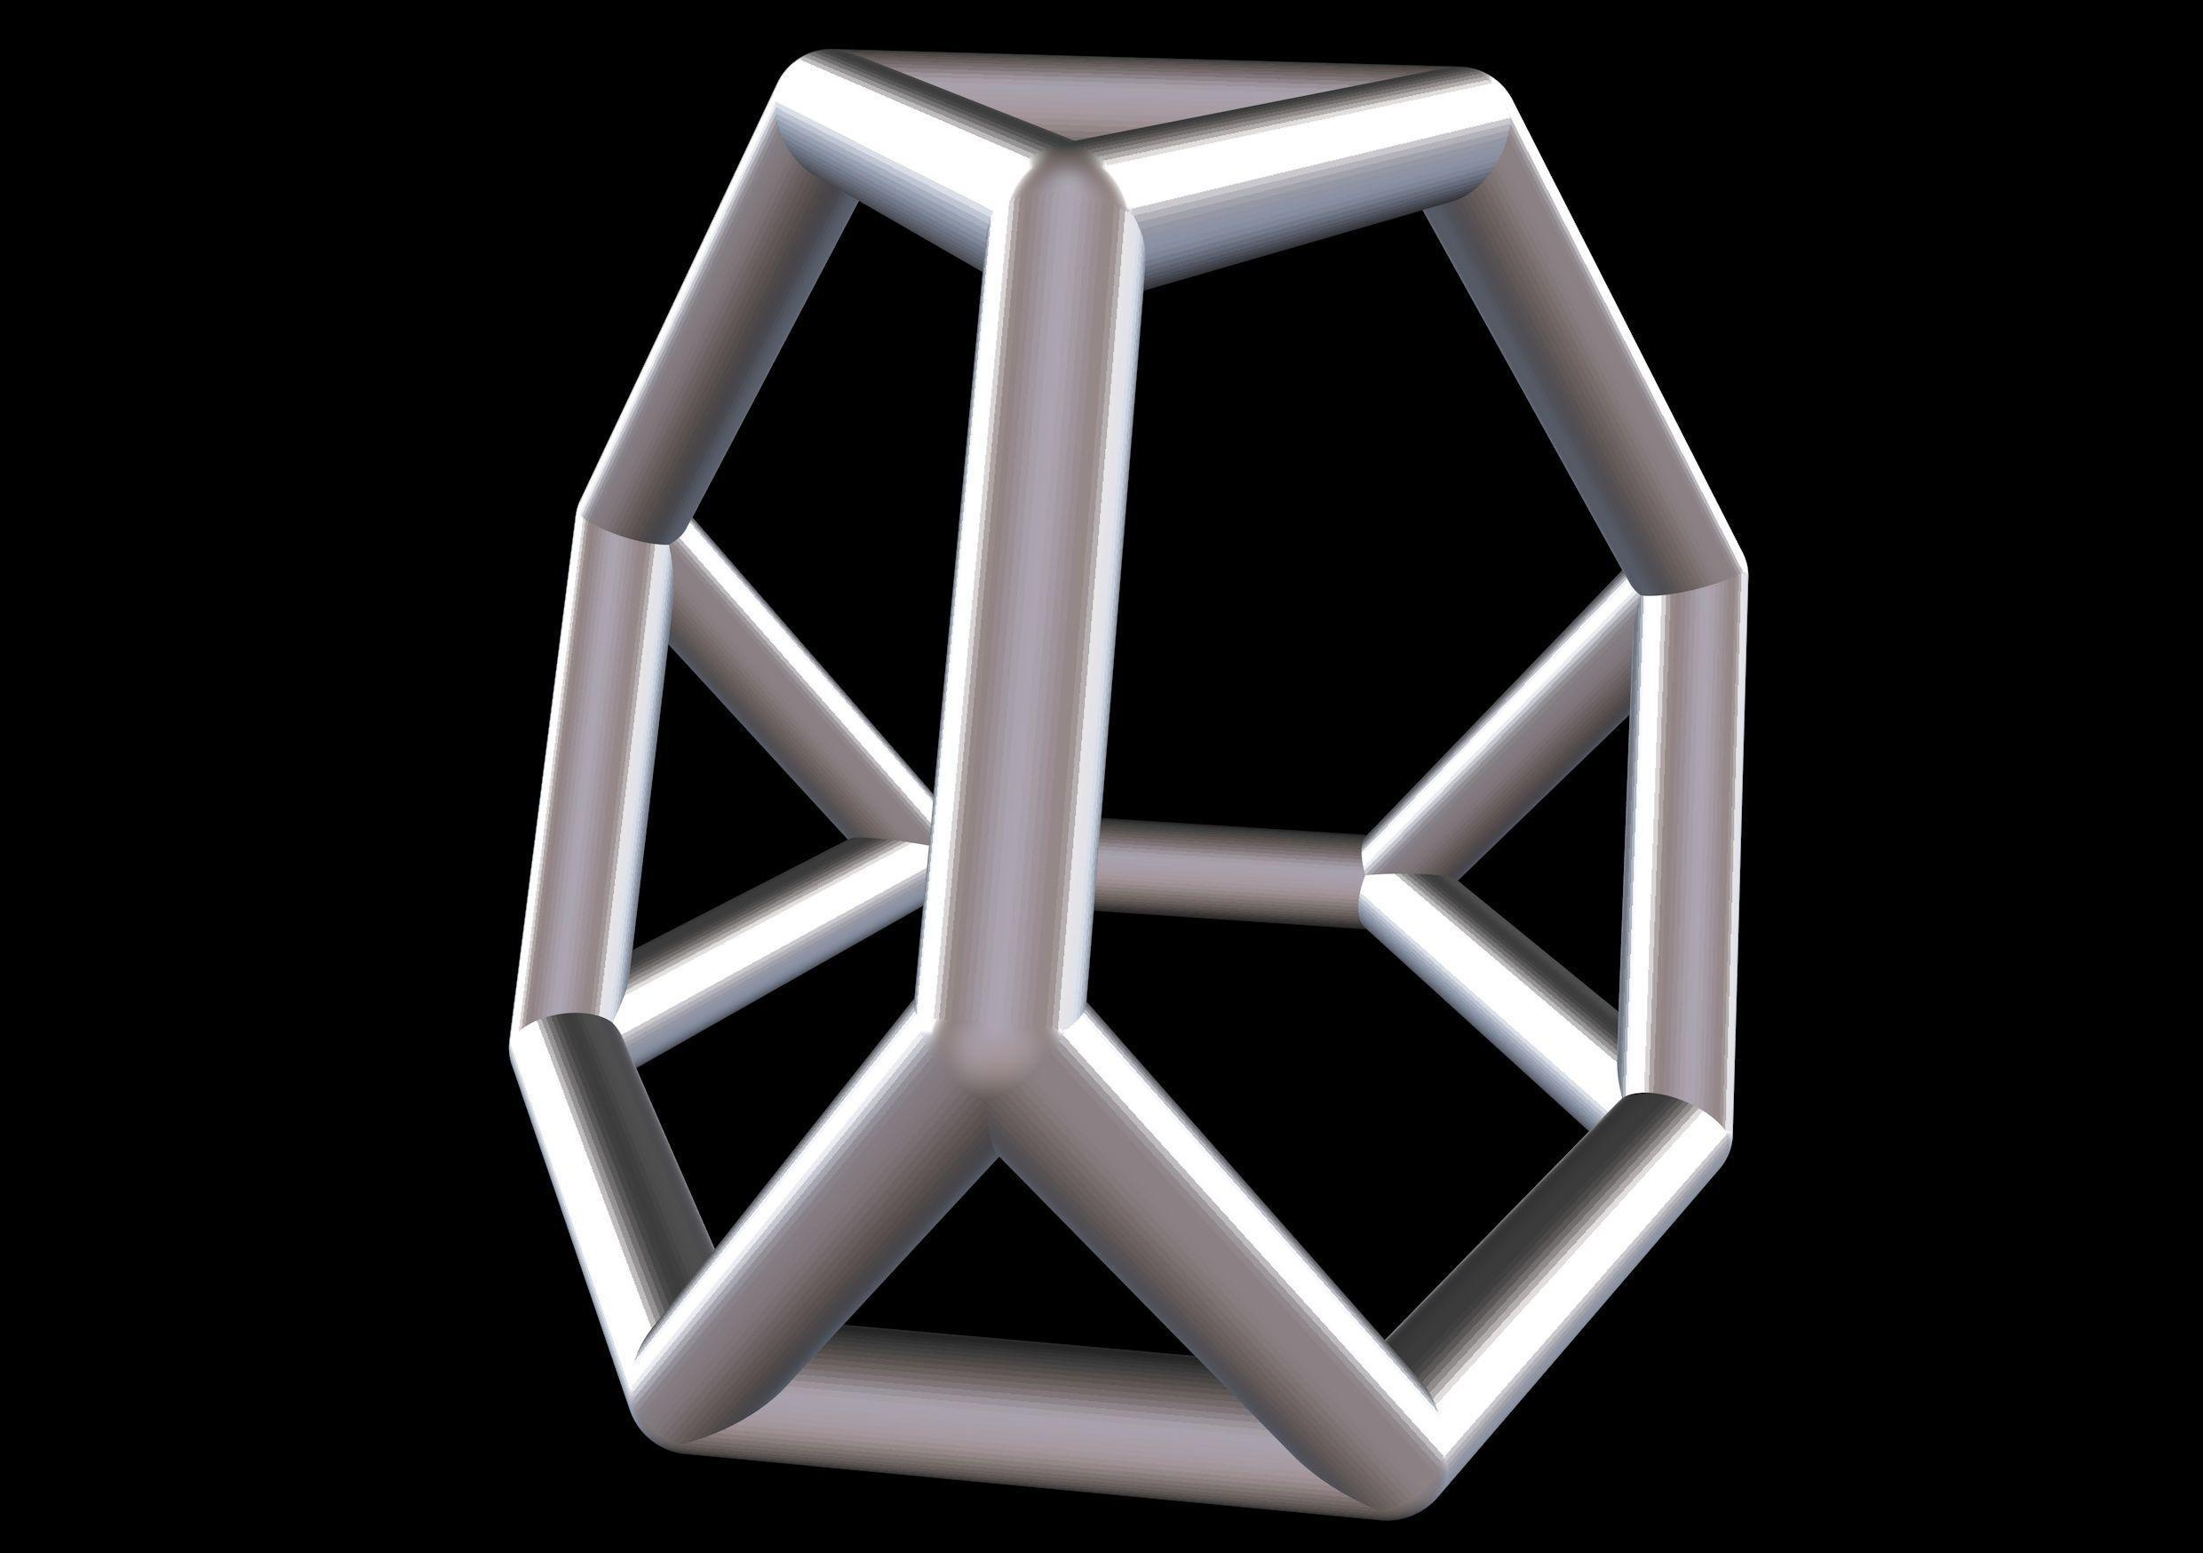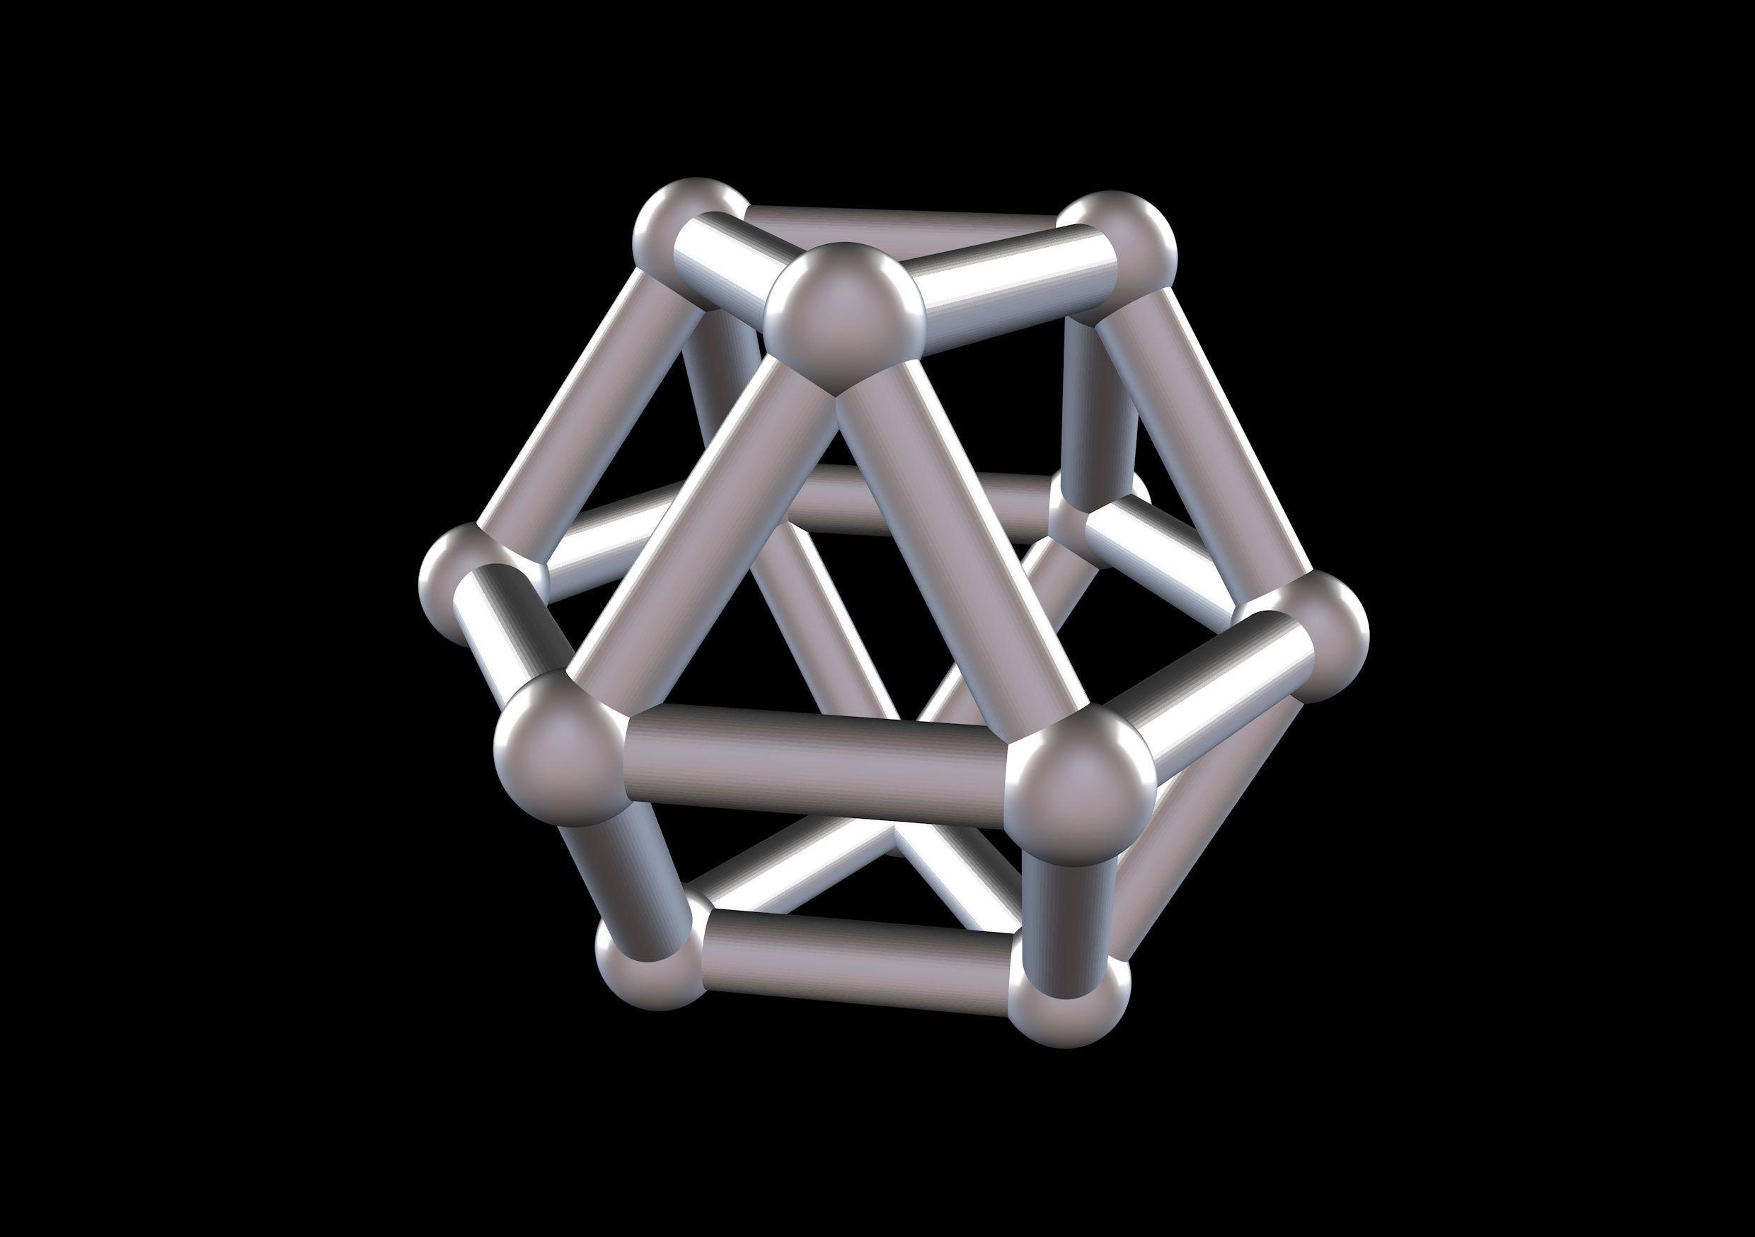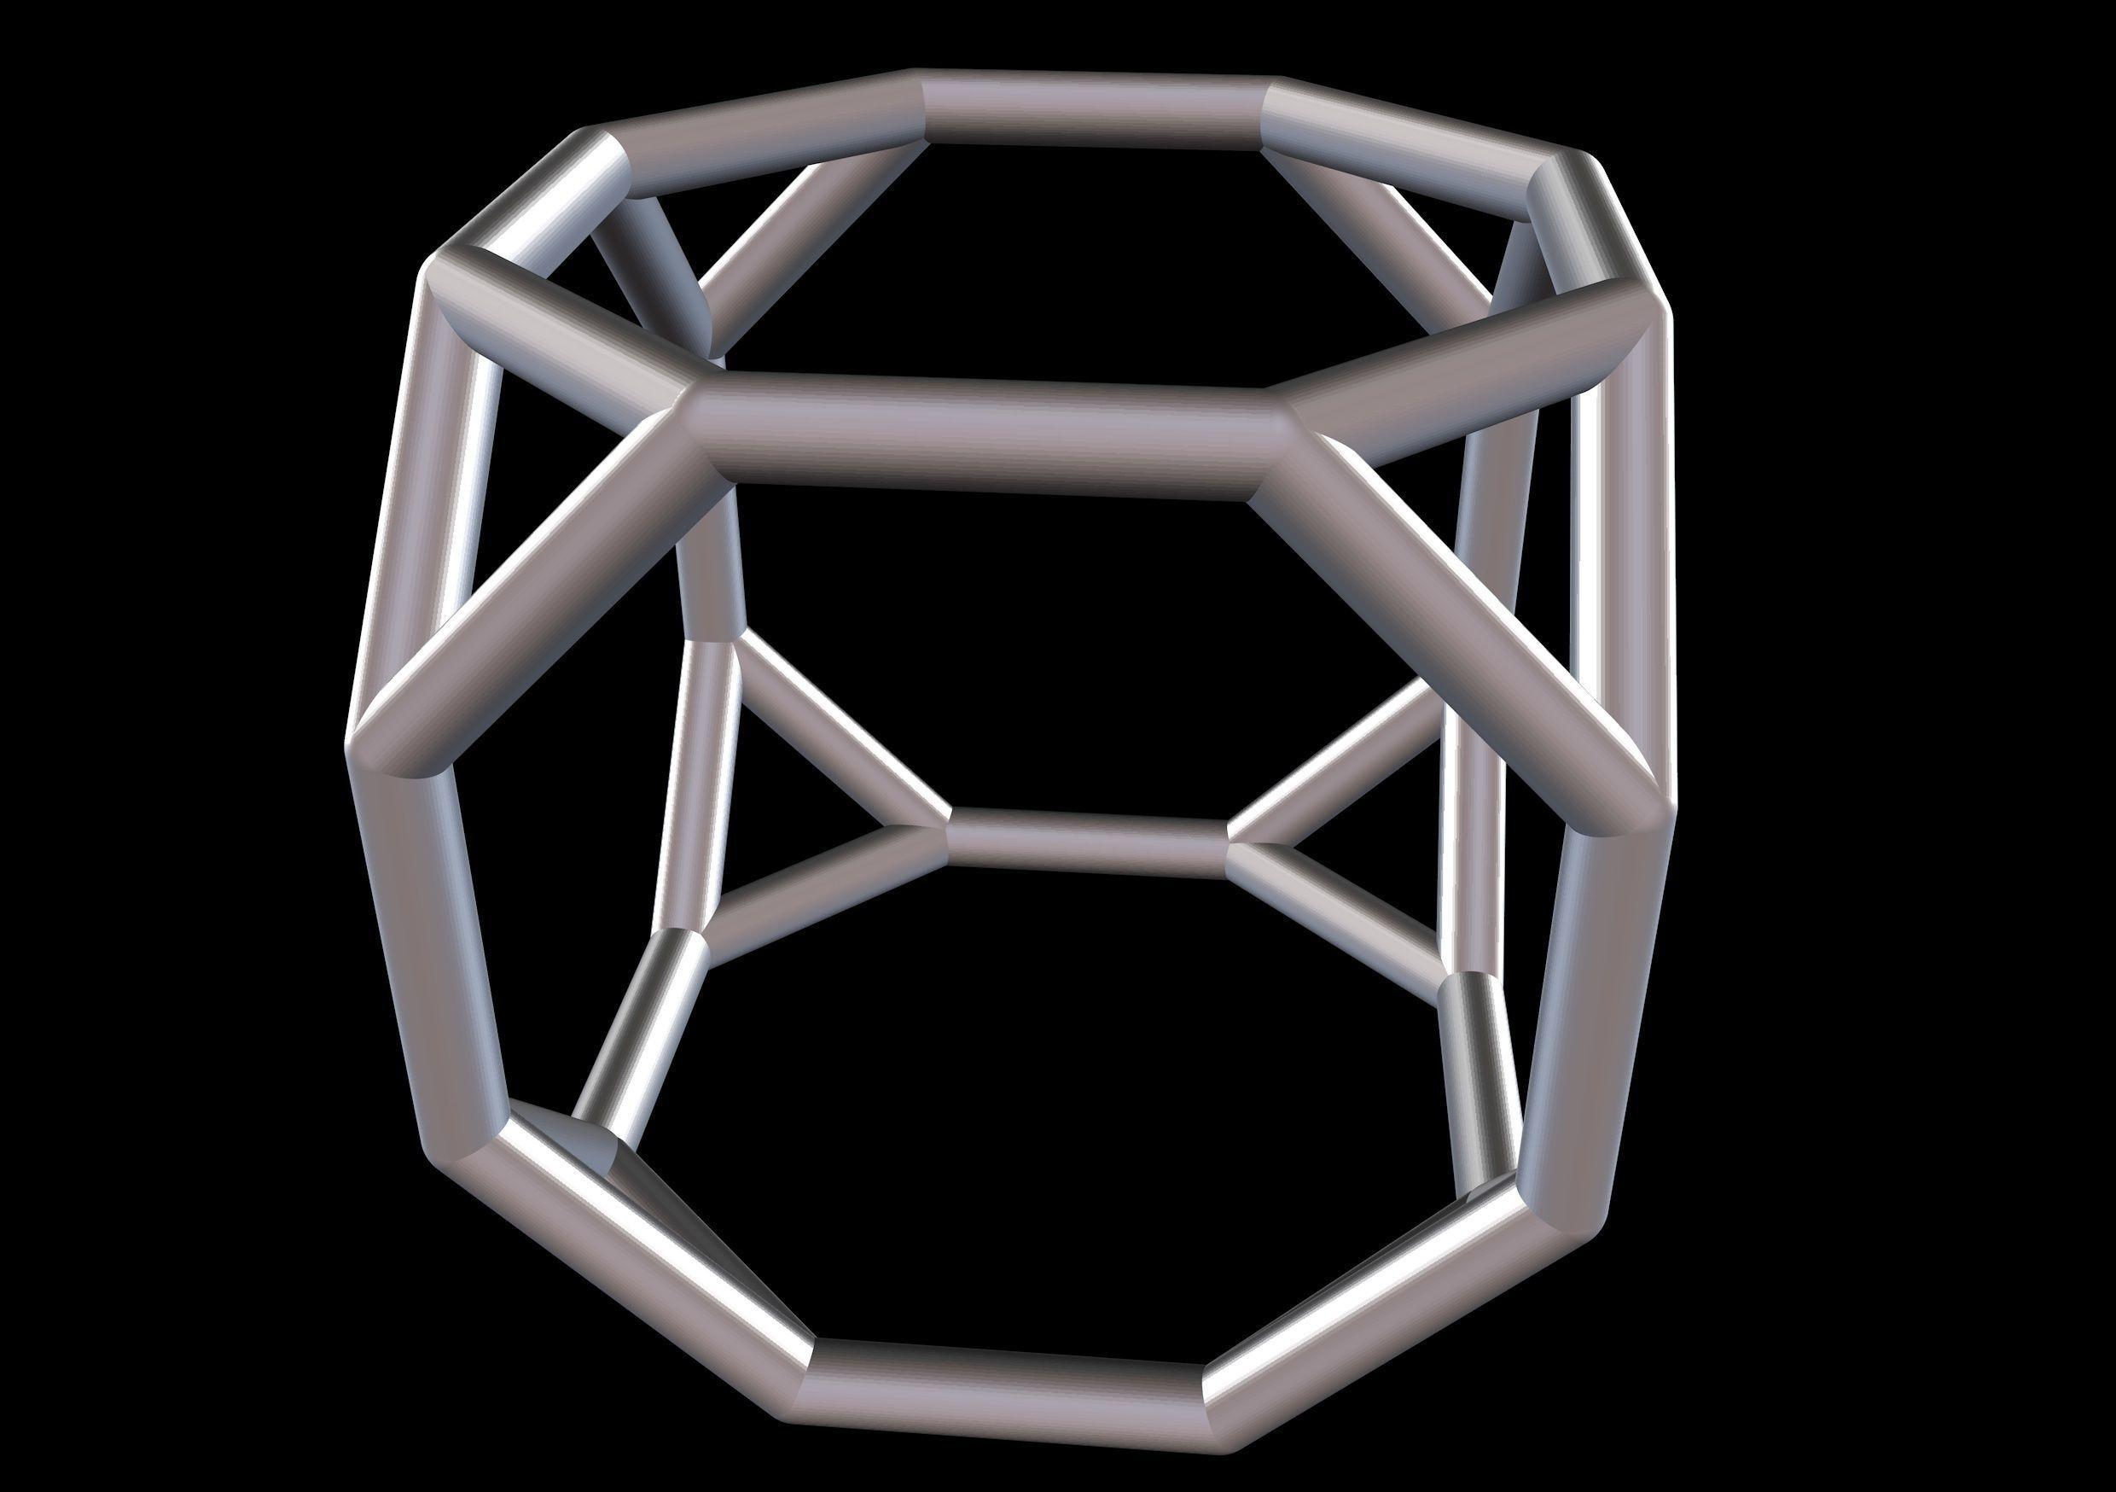

Truncated Tetrahedron
# Source: AI Source: Provided by: [Data Path: Persons Table -> ID Column: 1, Name_En Column: Motasem Essam] -> From: [ChatGPT] on [7/25/2026]
- 4 equilateral triangular faces.
- 4 regular hexagonal faces.

Cuboctahedron
# Source: AI Source: Provided by: [Data Path: Persons Table -> ID Column: 1, Name_En Column: Motasem Essam] -> From: [ChatGPT] on [7/25/2026]
- 8 equilateral triangular faces.
- 6 square faces.

Truncated Cube
# Source: AI Source: Provided by: [Data Path: Persons Table -> ID Column: 1, Name_En Column: Motasem Essam] -> From: [ChatGPT] on [7/25/2026]
- 8 equilateral triangular faces.
- 6 regular octagonal faces.

Truncated Octahedron
# Source: AI Source: Provided by: [Data Path: Persons Table -> ID Column: 1, Name_En Column: Motasem Essam] -> From: [ChatGPT] on [7/25/2026]
- 6 square faces.
- 8 regular hexagonal faces.
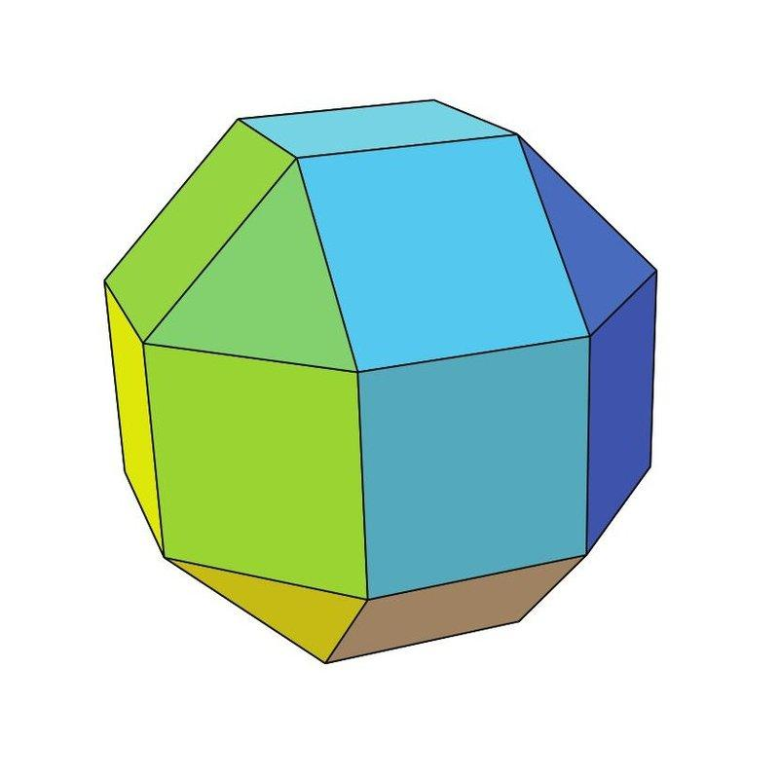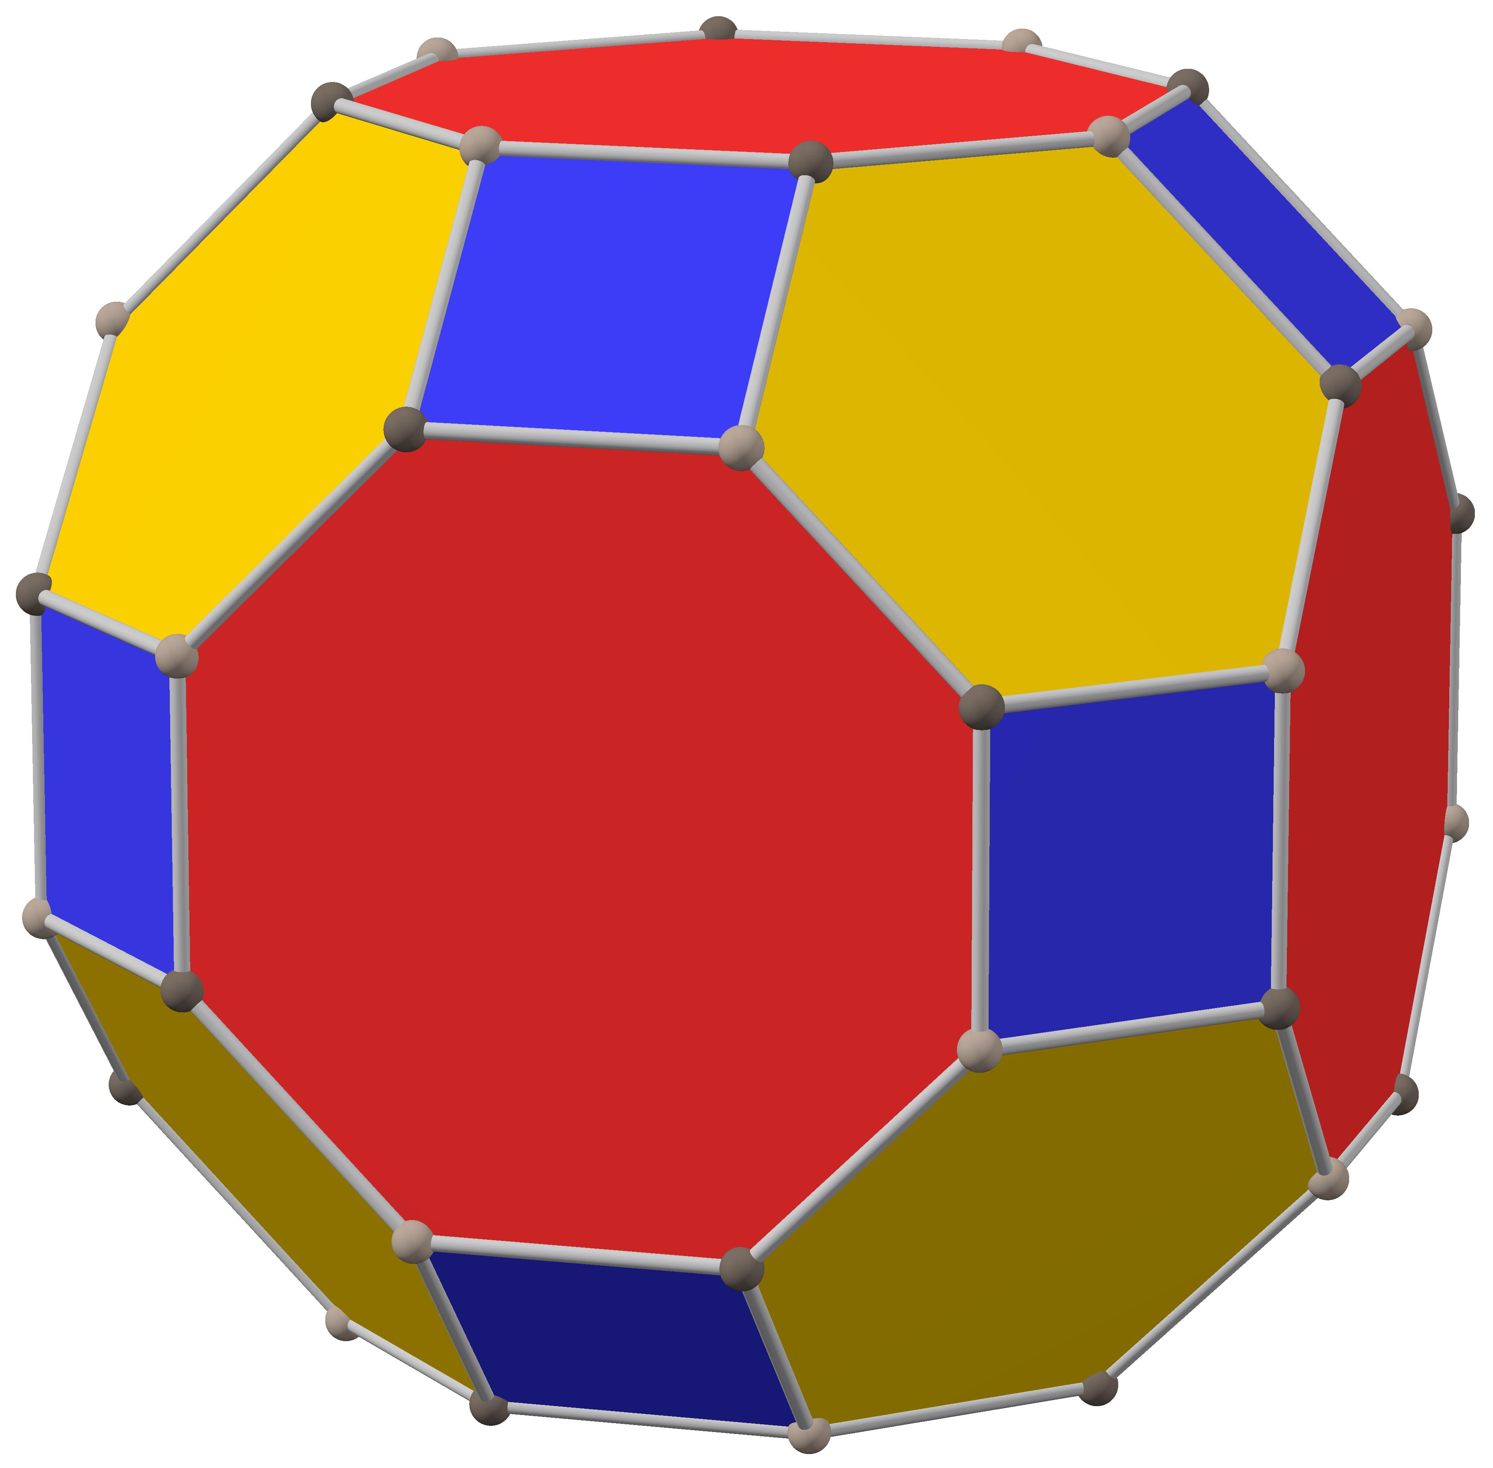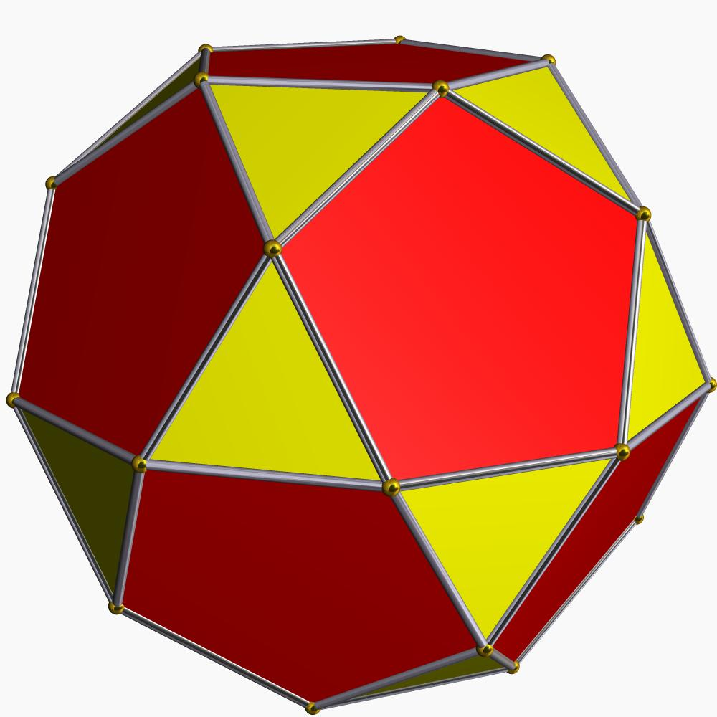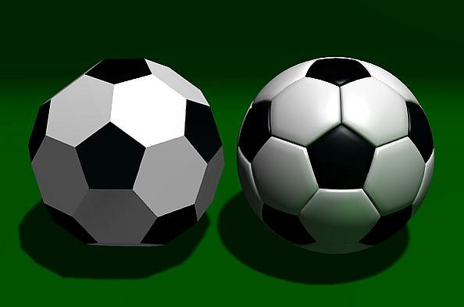

Rhombicuboctahedron (Small Rhombicuboctahedron)
# Source: AI Source: Provided by: [Data Path: Persons Table -> ID Column: 1, Name_En Column: Motasem Essam] -> From: [ChatGPT] on [7/25/2026]
- 8 equilateral triangular faces.
- 18 square faces.

Truncated Cuboctahedron (Great Rhombicuboctahedron)
# Source: AI Source: Provided by: [Data Path: Persons Table -> ID Column: 1, Name_En Column: Motasem Essam] -> From: [ChatGPT] on [7/25/2026]
- 12 square faces.
- 8 regular hexagonal faces.
- 6 regular octagonal faces.

Icosidodecahedron
# Source: AI Source: Provided by: [Data Path: Persons Table -> ID Column: 1, Name_En Column: Motasem Essam] -> From: [ChatGPT] on [7/25/2026]
- 20 equilateral triangular faces.
- 12 regular pentagonal faces.

Truncated Icosahedron
# Source: AI Source: Provided by: [Data Path: Persons Table -> ID Column: 1, Name_En Column: Motasem Essam] -> From: [ChatGPT] on [7/25/2026]
- 12 regular pentagonal faces.
- 20 regular hexagonal faces.
- Commonly known as the soccer-ball polyhedron.
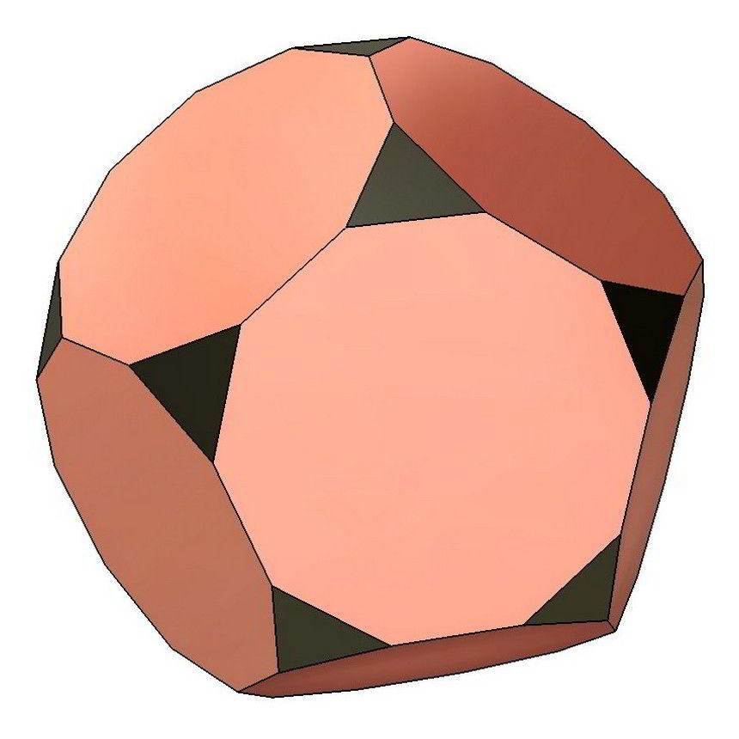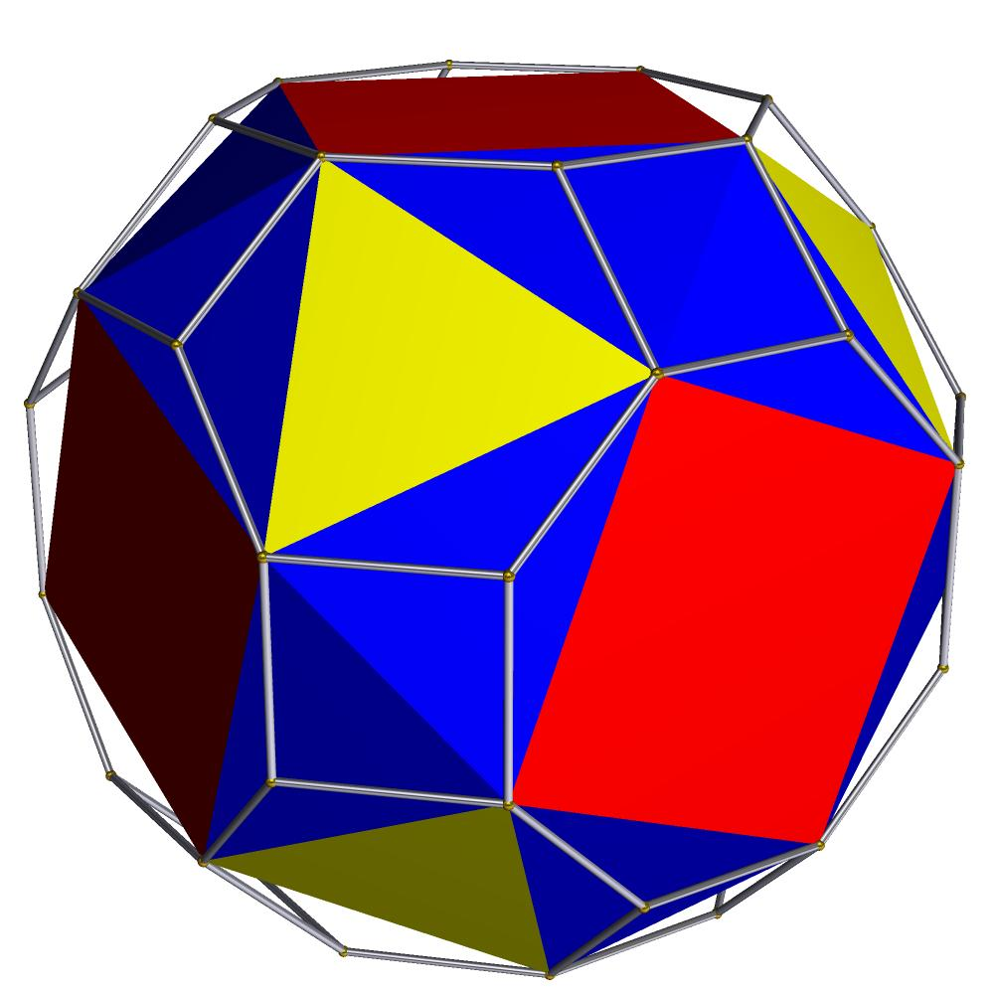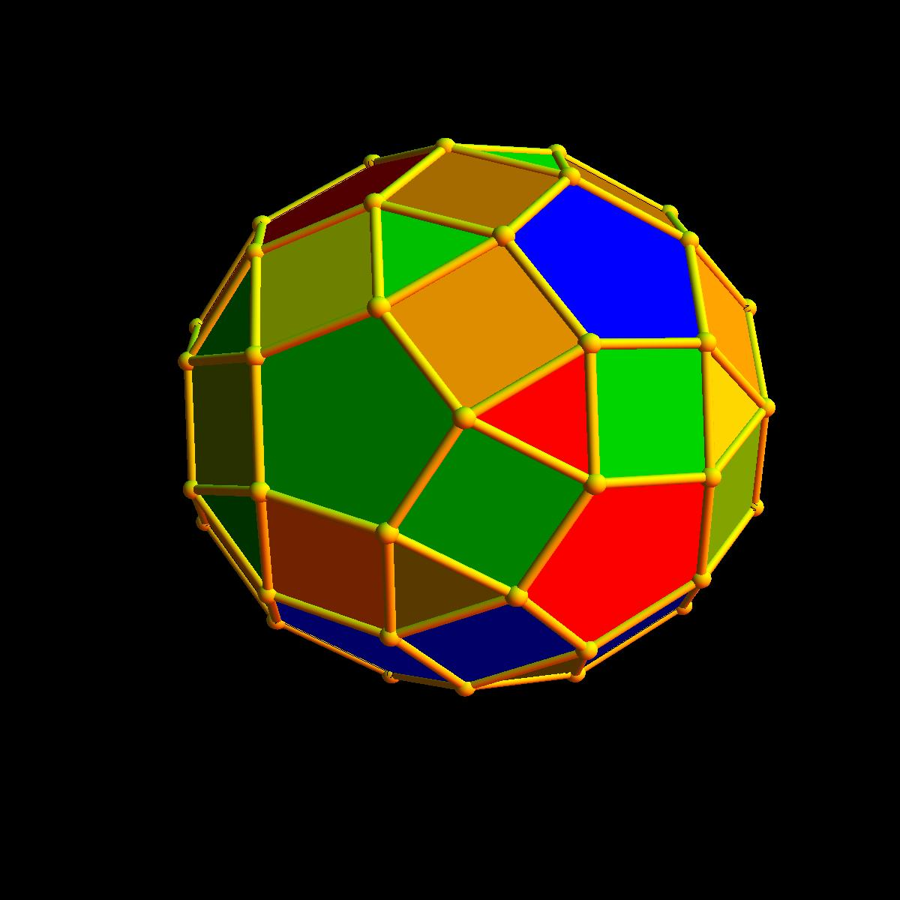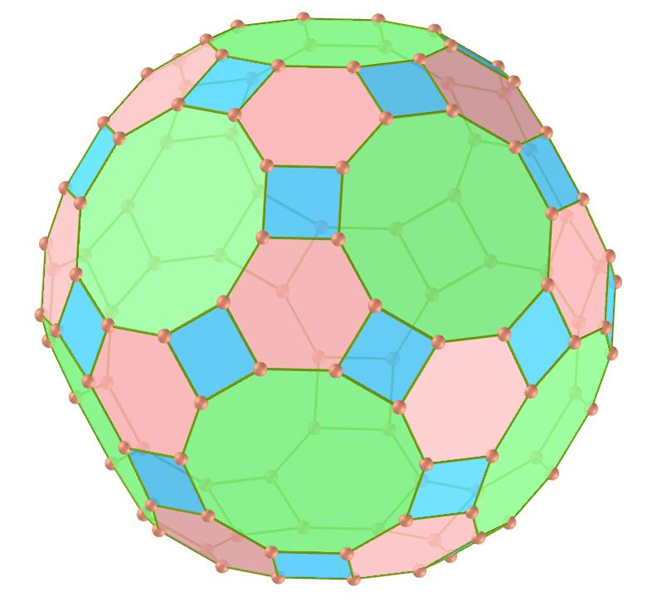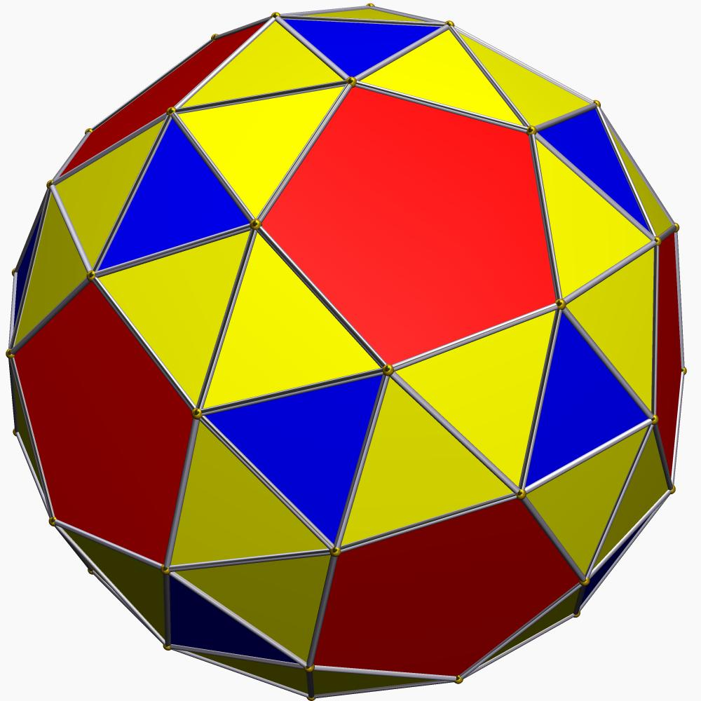

Truncated Dodecahedron
# Source: AI Source: Provided by: [Data Path: Persons Table -> ID Column: 1, Name_En Column: Motasem Essam] -> From: [ChatGPT] on [7/25/2026]
- 20 equilateral triangular faces.
- 12 regular decagonal faces.

Snub Cube
# Source: AI Source: Provided by: [Data Path: Persons Table -> ID Column: 1, Name_En Column: Motasem Essam] -> From: [ChatGPT] on [7/25/2026]
- 32 equilateral triangular faces.
- 6 square faces.

Rhombicosidodecahedron (Small Rhombicosidodecahedron)
# Source: AI Source: Provided by: [Data Path: Persons Table -> ID Column: 1, Name_En Column: Motasem Essam] -> From: [ChatGPT] on [7/25/2026]
- 20 equilateral triangular faces.
- 30 square faces.
- 12 regular pentagonal faces.

Truncated Icosidodecahedron (Great Rhombicosidodecahedron)
# Source: AI Source: Provided by: [Data Path: Persons Table -> ID Column: 1, Name_En Column: Motasem Essam] -> From: [ChatGPT] on [7/25/2026]
- 30 square faces.
- 20 regular hexagonal faces.
- 12 regular decagonal faces.

Snub Dodecahedron
# Source: AI Source: Provided by: [Data Path: Persons Table -> ID Column: 1, Name_En Column: Motasem Essam] -> From: [ChatGPT] on [7/25/2026]
- 80 equilateral triangular faces.
- 12 regular pentagonal faces.
<Cite refs={["turn766214search0","turn766214search2","turn766214search8"]}/>

Mathematical Properties
# Source: AI Source: Provided by: [Data Path: Persons Table -> ID Column: 1, Name_En Column: Motasem Essam] -> From: [ChatGPT] on [7/25/2026]
The defining mathematical properties of Archimedean solids include:
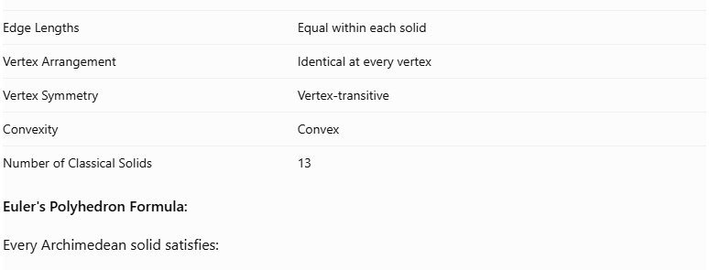
Property | Description
Solid Type | Convex polyhedron
Face Types | Two or more types of regular polygons
Edge Lengths | Equal within each solid
Vertex Arrangement | Identical at every vertex
Vertex Symmetry | Vertex-transitive
Convexity | Convex
Number of Classical Solids | 13
Euler's Polyhedron Formula:
Every Archimedean solid satisfies:
$$V-E+F=2$$
Where:
- $V$ = Number of vertices.
- $E$ = Number of edges.
- $F$ = Number of faces.
Vertex Configuration
The arrangement of polygons around each vertex can be represented by listing their side counts in cyclic order.
For example, the Cuboctahedron has vertex configuration:
$$(3,4,3,4)$$
This means that two triangles and two squares meet at every vertex, alternating around it. <Cite refs={["turn766214search0","turn766214search12"]}/>

Geometric Characteristics
# Source: AI Source: Provided by: [Data Path: Persons Table -> ID Column: 1, Name_En Column: Motasem Essam] -> From: [ChatGPT] on [7/25/2026]
- Face Shapes: Regular convex polygons.
- Face Composition: Multiple polygon types.
- Edge Structure: Equal edge lengths.
- Vertex Structure: Identical face arrangement at every vertex.
- Symmetry: Uniform polyhedral symmetry.
- Convexity: All classical Archimedean solids are convex.
- Construction Methods: Some are obtained by truncating or modifying Platonic solids; others, such as the snub solids, use twisting constructions.

Classification Distinctions
# Source: AI Source: Provided by: [Data Path: Persons Table -> ID Column: 1, Name_En Column: Motasem Essam] -> From: [ChatGPT] on [7/25/2026]
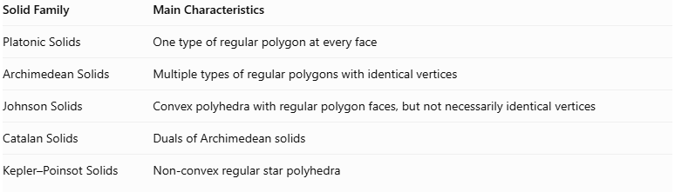
Solid Family | Main Characteristics
Platonic Solids | One type of regular polygon at every face
Archimedean Solids | Multiple types of regular polygons with identical vertices
Johnson Solids | Convex polyhedra with regular polygon faces, but not necessarily identical vertices
Catalan Solids | Duals of Archimedean solids
Kepler–Poinsot Solids | Non-convex regular star polyhedra
Important distinction: Regular prisms and antiprisms form separate infinite families and are excluded from the classical 13 Archimedean solids. <Cite refs={["turn766214search0","turn766214search1","turn766214search5"]}/>

Key Points
# Source: AI Source: Provided by: [Data Path: Persons Table -> ID Column: 1, Name_En Column: Motasem Essam] -> From: [ChatGPT] on [7/25/2026]
- There are 13 classical Archimedean solids.
- They are convex polyhedra with multiple types of regular polygonal faces.
- Every vertex has an identical arrangement of surrounding faces.
- All edges of each individual solid have equal length.
- They are different from Platonic solids, Johnson solids, and Catalan solids.
- The Catalan solids are the dual polyhedra of the Archimedean solids.

Main Classification
# Source: AI Source: Provided by: [Data Path: Persons Table -> ID Column: 1, Name_En Column: Motasem Essam] -> From: [ChatGPT] on [7/25/2026]
Solid Geometry
└── Types of Solids
└── Archimedean Solids
└── Types of Archimedean Solids
├── Truncated Tetrahedron
├── Cuboctahedron
├── Truncated Cube
├── Truncated Octahedron
├── Rhombicuboctahedron
├── Truncated Cuboctahedron
├── Icosidodecahedron
├── Truncated Icosahedron
├── Truncated Dodecahedron
├── Snub Cube
├── Rhombicosidodecahedron
├── Truncated Icosidodecahedron
└── Snub Dodecahedron

Conclusion
# Source: AI Source: Provided by: [Data Path: Persons Table -> ID Column: 1, Name_En Column: Motasem Essam] -> From: [ChatGPT] on [7/25/2026]
An Archimedean Solid is a convex uniform polyhedron made from multiple types of regular polygons, with an identical arrangement of faces around every vertex. The classical family contains 13 solids, including the Cuboctahedron, Icosidodecahedron, Truncated Icosahedron, and Snub Dodecahedron.

